UNISKILL: VERIFIED STUDENT SKILL EXCHANGE PLATFORM

A Synopsis for
Minor Project
BACHELOR OF TECHNOLOGY in COMPUTER SCIENCE & ENGINEERING
BY
Mohit Prajapati
EN23CS301634
Naman Dubey
EN23CS301650

Under the Guidance of

Prof. Rashmi Choudhary

Prof. Sonal Modh



Department of Computer Science & Engineering Faculty of Engineering
MEDICAPS UNIVERSITY, INDORE- 453331

APRIL 2026

- Introduction
- Literature Review
- Problem Definition
- Objectives
- Methodology
- References

Introduction
Core module: OTP-driven onboarding and university identity verification
Core module: Profile, learning goals, and teaching service management
Core module: Marketplace discovery for student mentors and campus peers
Core module: Session booking with room provisioning and lifecycle tracking
Core module: Credit wallet, transaction history, and peer transfers
Core module: Messaging, notifications, and WebRTC signaling
Core module: Supabase security hardening, audit logging, and verification vault design
The educational context for UniSkill is shaped by uneven access to tutoring, fragmented peer networks, and the absence of an institutional mechanism that lets students transparently monetize or exchange expertise without leaving the campus context.
UniSkill is conceived as a hybrid learning marketplace in which a student can discover another student by skill, reputation, and listed services, initiate a session request, and later move into a live room supported by signaling, chat, and structured status updates.
The repository reveals a multi-surface product rather than a static portal. The landing area introduces the product, the dashboard summarizes activity, the explore area surfaces mentors and service listings, the profile area controls skills and offerings, and route handlers persist the life cycle through Supabase-backed APIs.
This synopsis treats the project as both a deployable web application and an academic systems project, so the discussion covers user value, data integrity, security rules, implementation trade-offs, and measurable project outcomes.
Students usually find peer help through messaging groups, personal referrals, or chance interaction, which makes discovery unreliable and heavily biased toward existing social circles.
Learners often cannot compare teaching quality, availability, session structure, or expected cost before they commit to a session, so trust and decision quality remain low.
Students who can teach valuable skills have no structured campus-native system for building credibility, listing offers, and receiving value in a reusable campus economy.
Universities increasingly encourage collaborative learning, yet operational systems for verified peer exchange, credit flow, and accountable mentorship are usually absent.

Literature Review
Existing tutoring and freelance systems are either too generic, too commercially oriented, or too weak on institutional trust. UniSkill fills the gap by combining campus identity, peer-to-peer service exchange, educational intent, and a reusable credits model inside one coherent architecture.
Design note for primary stakeholder expectations: the feature must remain understandable for a first-time student user.
Technical note for primary stakeholder expectations: API, schema, and UI state should remain synchronized.
Quality note for primary stakeholder expectations: failures should preserve traceability and user confidence.
Design note for learner success metrics: the feature must remain understandable for a first-time student user.
Technical note for learner success metrics: API, schema, and UI state should remain synchronized.
Quality note for learner success metrics: failures should preserve traceability and user confidence.
Design note for mentor motivation structure: the feature must remain understandable for a first-time student user.
Technical note for mentor motivation structure: API, schema, and UI state should remain synchronized.
Quality note for mentor motivation structure: failures should preserve traceability and user confidence.

Problem Definition
Existing tutoring and freelance systems are either too generic, too commercially oriented, or too weak on institutional trust. UniSkill fills the gap by combining campus identity, peer-to-peer service exchange, educational intent, and a reusable credits model inside one coherent architecture.
Design note for campus trust and institutional concerns: the feature must remain understandable for a first-time student user.
Technical note for campus trust and institutional concerns: API, schema, and UI state should remain synchronized.
Quality note for campus trust and institutional concerns: failures should preserve traceability and user confidence.
Design note for adoption barriers in the early pilot phase: the feature must remain understandable for a first-time student user.
Technical note for adoption barriers in the early pilot phase: API, schema, and UI state should remain synchronized.
Quality note for adoption barriers in the early pilot phase: failures should preserve traceability and user confidence.
Design note for marketplace liquidity strategy: the feature must remain understandable for a first-time student user.
Technical note for marketplace liquidity strategy: API, schema, and UI state should remain synchronized.
Quality note for marketplace liquidity strategy: failures should preserve traceability and user confidence.
Design note for credit-economy sustainability assumptions: the feature must remain understandable for a first-time student user.
Technical note for credit-economy sustainability assumptions: API, schema, and UI state should remain synchronized.
Quality note for credit-economy sustainability assumptions: failures should preserve traceability and user confidence.
Design note for support and moderation considerations: the feature must remain understandable for a first-time student user.
Technical note for support and moderation considerations: API, schema, and UI state should remain synchronized.
Quality note for support and moderation considerations: failures should preserve traceability and user confidence.

Objectives
Build a verified skill exchange platform tailored to university students and lightweight enough for repeated daily use.
Design a modular architecture in which frontend, backend, realtime transport, and Supabase persistence can evolve independently.
Establish a trust framework through OTP verification, private verification vault storage, and role-based data access rules.
Create a sustainable credit economy that rewards teaching, tracks transfers, and preserves a clear financial-style audit trail.
Support mentorship discovery and booking through profile signals, service listings, session creation, and real-time follow-up.
Provide an extensible base for future admin analytics, dispute management, automated matchmaking, and institutional rollout.

Methodology
Account creation, login, OTP dispatch, and verification status tracking
Profile compatibility layer for both legacy and reconciled Supabase schema fields
Marketplace exploration for mentors and service listings
Session record creation and room identifier generation
Wallet viewing, credit purchase simulation, and credit transfer routes
Realtime signaling and chat events through Socket.io rooms
5.1 is strengthened by the fact that UniSkill already demonstrates a working integration pattern across interface, API endpoints, and schema migration artifacts.
Students already use browsers and mobile-responsive portals as their default campus interaction surface.
The system stack runs on mainstream developer tools and does not require unusual local hardware.
Supabase reduces infrastructure friction by combining auth, database, storage, and policy controls.
5.2 is strengthened by the fact that UniSkill already demonstrates a working integration pattern across interface, API endpoints, and schema migration artifacts.
The chosen stack is mature, well-supported, and already represented in the repository.
Data-intensive requirements are moderate, making PostgreSQL and RLS an appropriate fit.
The architecture can be deployed incrementally, allowing staged validation of each module.
5.3 is strengthened by the fact that UniSkill already demonstrates a working integration pattern across interface, API endpoints, and schema migration artifacts.
The platform can begin on low-cost managed services while serving a limited campus cohort.
Virtual credits minimize payment gateway dependence during early validation phases.
Reuse of open-source frameworks reduces capital expenditure for prototyping and iteration.
5.4 is strengthened by the fact that UniSkill already demonstrates a working integration pattern across interface, API endpoints, and schema migration artifacts.
An incremental and feedback-driven methodology suits UniSkill because user experience, trust flow, and schema evolution influence one another. The repository shows iterative refinement, including schema reconciliation migrations, compatibility handling inside the frontend auth context, and modular route definition in the backend.
From a project management standpoint, the work can be framed as an agile campus product: onboarding and profile flows validate trust assumptions first, marketplace and service listing flows validate discoverability, and session plus wallet features validate the exchange model.
The architecture is layered but not rigidly monolithic. Client pages in the Next.js app own user interaction and SSR-aware session handling. Route handlers provide server-side mediation for profiles, sessions, and service listings. Express routes handle OTP, wallet behavior, auth-specific logic, and realtime event transport. Supabase anchors identity, relational storage, and security policy enforcement.
This module covers registration, login, OTP sending, OTP verification, verification status checks, and secure session persistence. It is central to the overall value proposition because it turns the abstract idea of student skill exchange into a repeatable operational flow.
This module covers student-facing profile editing, compatibility mapping, public trust indicators, and teaching or learning metadata. It is central to the overall value proposition because it turns the abstract idea of student skill exchange into a repeatable operational flow.
This module covers mentor exploration, filters, skill matching, service listing retrieval, and campus-oriented categorization. It is central to the overall value proposition because it turns the abstract idea of student skill exchange into a repeatable operational flow.
This module covers booking initiation, room creation, pending and confirmed states, realtime handoff, and session completion intent. It is central to the overall value proposition because it turns the abstract idea of student skill exchange into a repeatable operational flow.
This module covers wallet snapshots, transaction history, credit top-up simulation, and peer transfer logic. It is central to the overall value proposition because it turns the abstract idea of student skill exchange into a repeatable operational flow.
This module covers Socket.io room join events, signal relay, chat message propagation, and call termination notifications. It is central to the overall value proposition because it turns the abstract idea of student skill exchange into a repeatable operational flow.
This module covers verification review, dispute handling, analytics, and trust moderation envisioned over the current base. It is central to the overall value proposition because it turns the abstract idea of student skill exchange into a repeatable operational flow.
Hardware requirements remain modest for development, while production planning should emphasize network reliability, managed database throughput, secure secret storage, and observability around authentication and booking flows.
Schema drift between frontend expectations and live database structure
Weak verification if OTP and vault flows are not tightly validated
Credit inconsistencies if transfer operations are not wrapped in stronger transaction discipline
Realtime instability under poor networks or abrupt room exits
Each of these concerns is directly relevant to UniSkill because the product only succeeds when trust, session completion, and balance integrity work together as one operational chain.
Unit testing for validation helpers and route-level business checks
Integration tests for auth, session creation, and wallet transfer paths
UI scenario tests for signup, profile updates, mentor discovery, and room entry
Security verification of RLS behavior and sensitive-field exposure
Deploy frontend and backend separately but with aligned environment variables and origin rules
Use Supabase migrations as the canonical database change log
Monitor auth success, OTP delivery, booking completion, and transfer failure rates from the first pilot cohort
AI-assisted mentor recommendation based on learning goals and prior outcomes.
Institution admin console for verification review, trust intervention, and usage analytics.
Calendar integration, reminders, and richer availability scheduling.
Session evidence capture, refunds, and dispute escalation workflows.
Cross-campus federation with domain-specific verification controls.
Design note for communication and onboarding campaign ideas: the feature must remain understandable for a first-time student user.
Technical note for communication and onboarding campaign ideas: API, schema, and UI state should remain synchronized.
Quality note for communication and onboarding campaign ideas: failures should preserve traceability and user confidence.
Design note for rollout sequencing for campus launch: the feature must remain understandable for a first-time student user.
Technical note for rollout sequencing for campus launch: API, schema, and UI state should remain synchronized.
Quality note for rollout sequencing for campus launch: failures should preserve traceability and user confidence.
Design note for signup and identity capture scenario: the feature must remain understandable for a first-time student user.
Technical note for signup and identity capture scenario: API, schema, and UI state should remain synchronized.
Quality note for signup and identity capture scenario: failures should preserve traceability and user confidence.
Design note for otp verification scenario: the feature must remain understandable for a first-time student user.
Technical note for otp verification scenario: API, schema, and UI state should remain synchronized.
Quality note for otp verification scenario: failures should preserve traceability and user confidence.
Design note for profile completion and mentor activation: the feature must remain understandable for a first-time student user.
Technical note for profile completion and mentor activation: API, schema, and UI state should remain synchronized.
Quality note for profile completion and mentor activation: failures should preserve traceability and user confidence.
Design note for teaching-service publication lifecycle: the feature must remain understandable for a first-time student user.
Technical note for teaching-service publication lifecycle: API, schema, and UI state should remain synchronized.
Quality note for teaching-service publication lifecycle: failures should preserve traceability and user confidence.
Design note for mentor discovery and comparison: the feature must remain understandable for a first-time student user.
Technical note for mentor discovery and comparison: API, schema, and UI state should remain synchronized.
Quality note for mentor discovery and comparison: failures should preserve traceability and user confidence.
Design note for booking confirmation and room preparation: the feature must remain understandable for a first-time student user.
Technical note for booking confirmation and room preparation: API, schema, and UI state should remain synchronized.
Quality note for booking confirmation and room preparation: failures should preserve traceability and user confidence.
Design note for wallet top-up and transfer interpretation: the feature must remain understandable for a first-time student user.
Technical note for wallet top-up and transfer interpretation: API, schema, and UI state should remain synchronized.
Quality note for wallet top-up and transfer interpretation: failures should preserve traceability and user confidence.
Design note for realtime room participation flow: the feature must remain understandable for a first-time student user.
Technical note for realtime room participation flow: API, schema, and UI state should remain synchronized.
Quality note for realtime room participation flow: failures should preserve traceability and user confidence.
Design note for review and feedback closure: the feature must remain understandable for a first-time student user.
Technical note for review and feedback closure: API, schema, and UI state should remain synchronized.
Quality note for review and feedback closure: failures should preserve traceability and user confidence.
Design note for maintenance and future admin intervention points: the feature must remain understandable for a first-time student user.
Technical note for maintenance and future admin intervention points: API, schema, and UI state should remain synchronized.
Quality note for maintenance and future admin intervention points: failures should preserve traceability and user confidence.
Design note for happy-path registration: the feature must remain understandable for a first-time student user.
Technical note for happy-path registration: API, schema, and UI state should remain synchronized.
Quality note for happy-path registration: failures should preserve traceability and user confidence.
Design note for duplicate profile handling: the feature must remain understandable for a first-time student user.
Technical note for duplicate profile handling: API, schema, and UI state should remain synchronized.
Quality note for duplicate profile handling: failures should preserve traceability and user confidence.
Design note for admin-key fallback behavior: the feature must remain understandable for a first-time student user.
Technical note for admin-key fallback behavior: API, schema, and UI state should remain synchronized.
Quality note for admin-key fallback behavior: failures should preserve traceability and user confidence.
Design note for wallet insufficient-balance flow: the feature must remain understandable for a first-time student user.
Technical note for wallet insufficient-balance flow: API, schema, and UI state should remain synchronized.
Quality note for wallet insufficient-balance flow: failures should preserve traceability and user confidence.
Design note for mentor listing ownership checks: the feature must remain understandable for a first-time student user.
Technical note for mentor listing ownership checks: API, schema, and UI state should remain synchronized.
Quality note for mentor listing ownership checks: failures should preserve traceability and user confidence.
Design note for session-room creation verification: the feature must remain understandable for a first-time student user.
Technical note for session-room creation verification: API, schema, and UI state should remain synchronized.
Quality note for session-room creation verification: failures should preserve traceability and user confidence.
Design note for rls privacy boundary validation: the feature must remain understandable for a first-time student user.
Technical note for rls privacy boundary validation: API, schema, and UI state should remain synchronized.
Quality note for rls privacy boundary validation: failures should preserve traceability and user confidence.
Design note for realtime disconnect recovery: the feature must remain understandable for a first-time student user.
Technical note for realtime disconnect recovery: API, schema, and UI state should remain synchronized.
Quality note for realtime disconnect recovery: failures should preserve traceability and user confidence.
Design note for cross-origin configuration checks: the feature must remain understandable for a first-time student user.
Technical note for cross-origin configuration checks: API, schema, and UI state should remain synchronized.
Quality note for cross-origin configuration checks: failures should preserve traceability and user confidence.
Design note for post-deployment monitoring expectations: the feature must remain understandable for a first-time student user.
Technical note for post-deployment monitoring expectations: API, schema, and UI state should remain synchronized.
Quality note for post-deployment monitoring expectations: failures should preserve traceability and user confidence.
This appendix summarizes how the UniSkill project can be demonstrated in an academic review setting. The goal is to show that the product is not only conceptually designed, but also organized around a believable end-to-end student workflow.
Begin with the landing experience and explain the campus-first value proposition of UniSkill: verified students exchanging skills, mentoring, and guided sessions inside one controlled platform.
Show student signup, OTP verification, and profile creation. This step establishes the trust model and explains why identity verification is central to the project.
Move into marketplace discovery where a learner filters profiles, inspects mentor offerings, and selects a relevant service. This proves that the project solves the discovery problem defined earlier in the synopsis.
Demonstrate booking confirmation, wallet interaction, and session lifecycle state changes so evaluators can see how value exchange and accountability are tied together.
Finish with room participation, feedback submission, and notification behavior to show that UniSkill supports the complete mentoring loop rather than stopping at simple profile browsing.
Faculty review of the synopsis usually depends on whether the team can connect the problem statement, objectives, architecture, modules, and expected outcomes into one coherent explanation. The following compact matrix helps structure that discussion.
Adding this appendix keeps the synopsis aligned with real project presentation needs while staying fully focused on UniSkill instead of the unrelated SQL optimizer content found in the original target file.
The strongest closing message for the synopsis is that UniSkill is not just a marketplace idea, but a structured campus system that combines discovery, trust, session control, and credit accountability into one coherent workflow.
This framing helps evaluators see the project as both technically grounded and socially relevant: it addresses a real student need while demonstrating modern full-stack engineering, data security awareness, and platform design discipline.
By the end of the presentation, the audience should clearly understand the problem, the proposed solution, the major modules, the implementation approach, and the practical value of deploying UniSkill inside a university environment.

Layer | Technology | Role in UniSkill
Frontend | Next.js 16, React 19, Tailwind CSS 4 | Public website, onboarding, profile and marketplace experiences
Backend | Express 5, TypeScript, Socket.io | OTP, wallet, sessions, realtime signaling and business routes
Platform Services | Supabase Auth, PostgreSQL, RLS, Storage | Identity, persistence, protected data access and storage

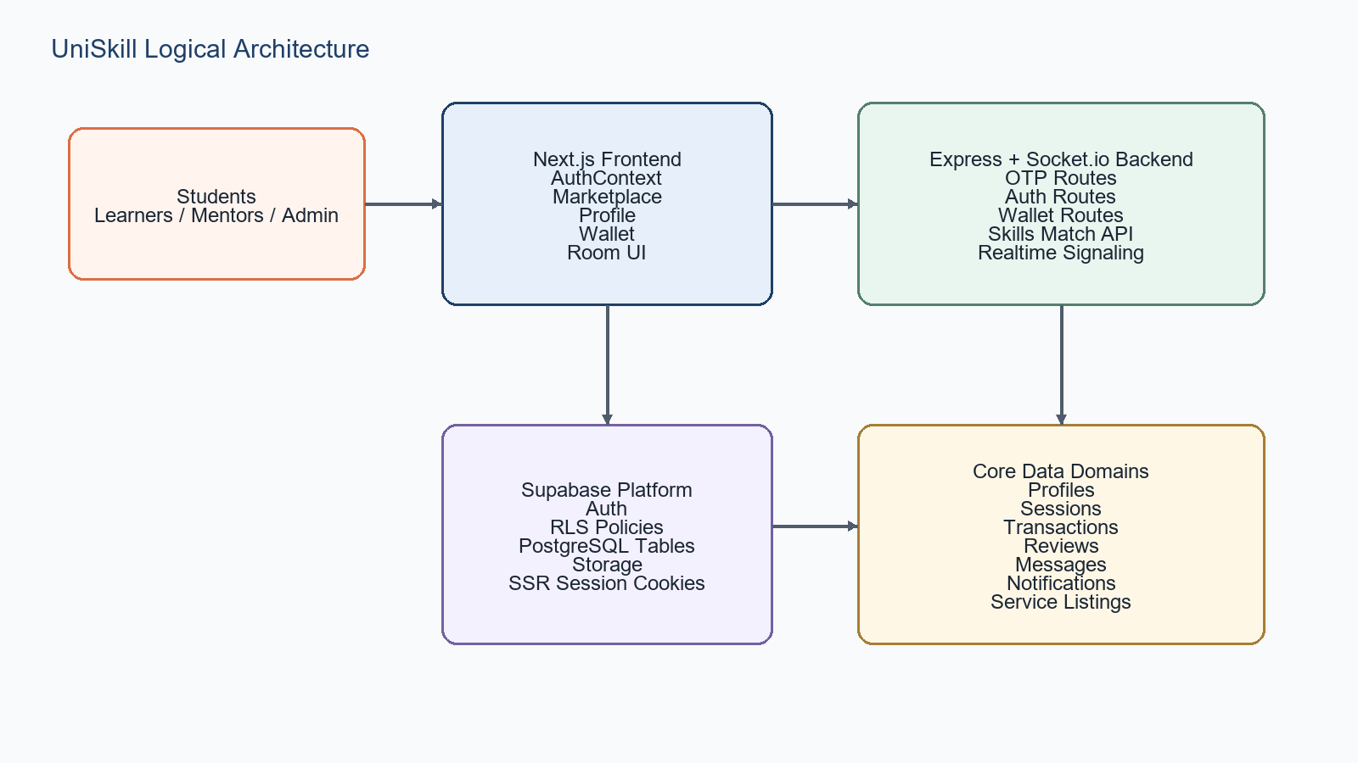
Figure: UniSkill logical architecture overview

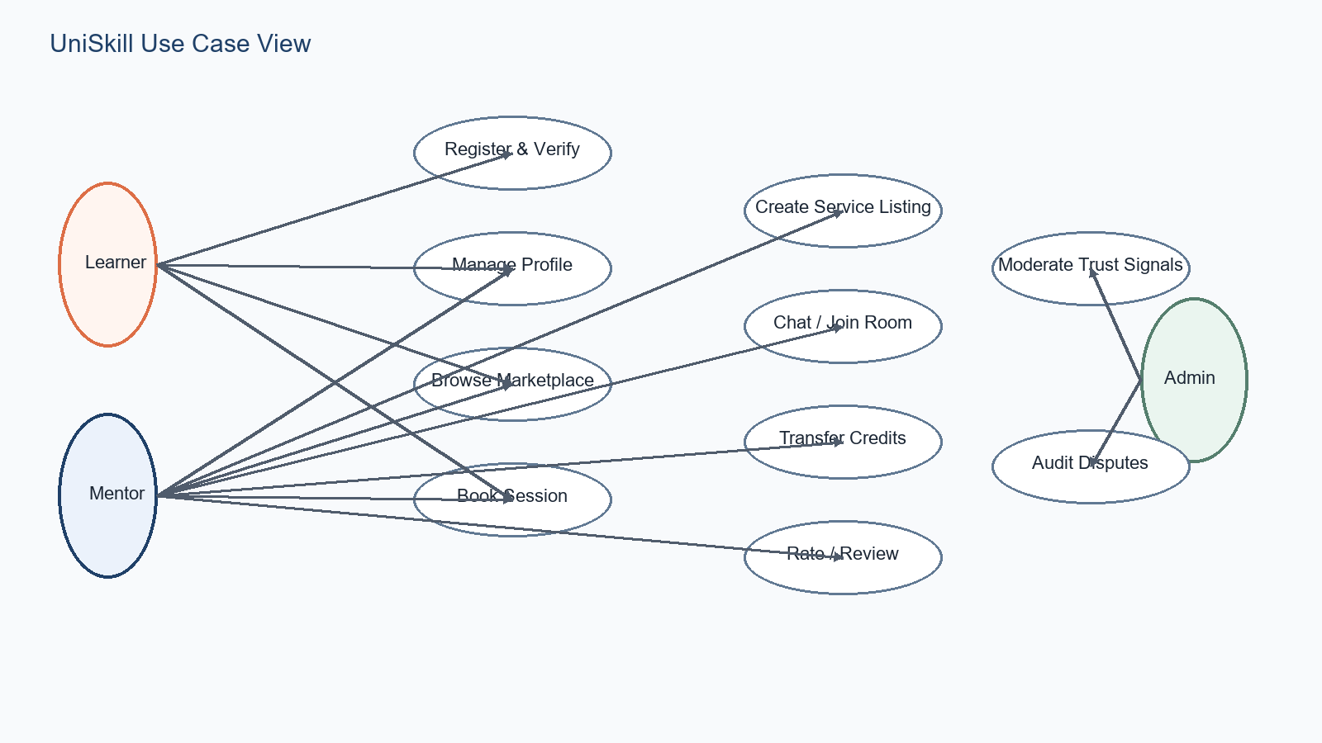
Figure: UniSkill use case overview
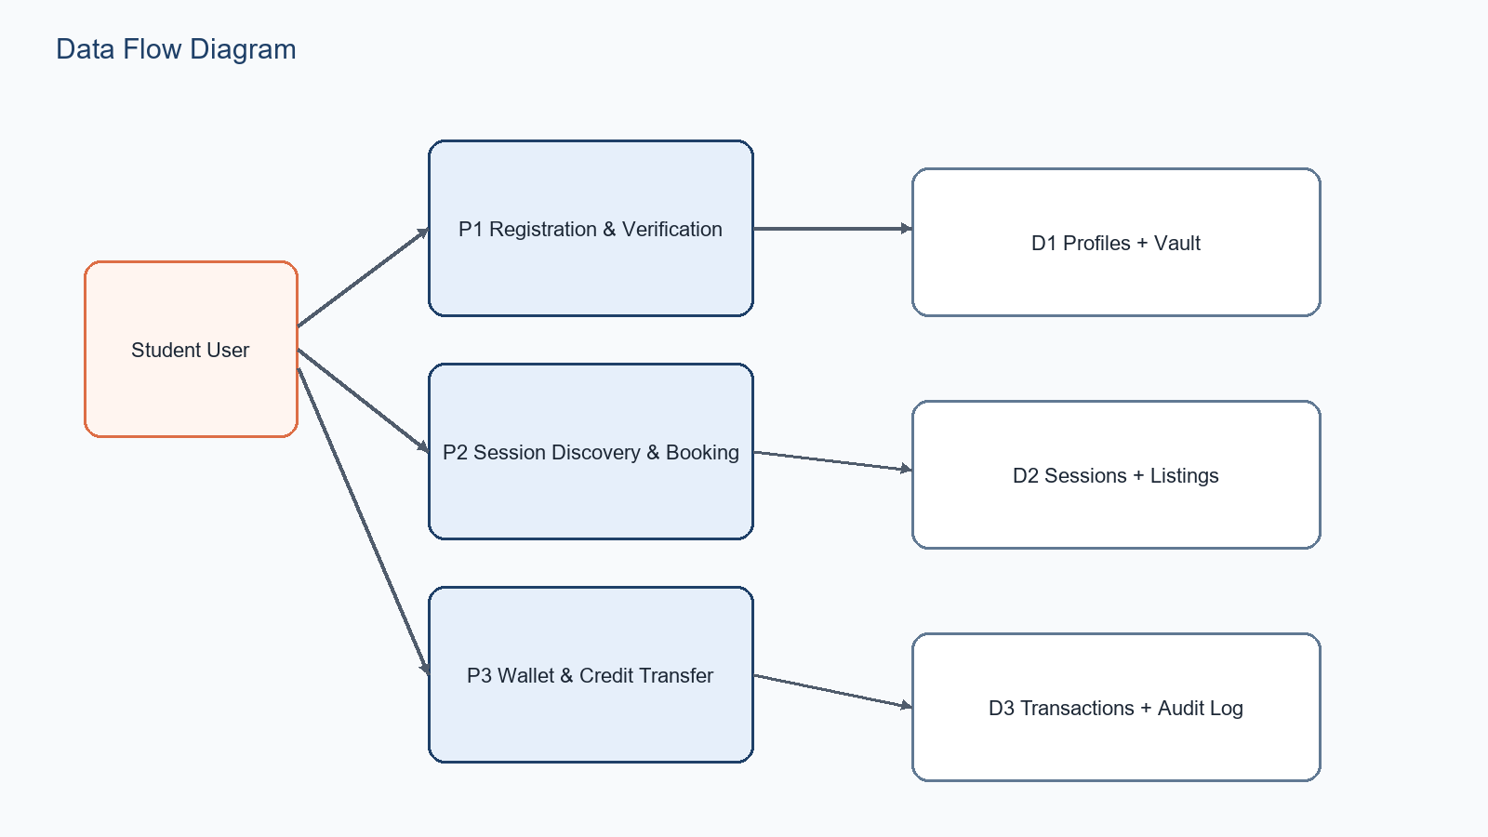
Figure: UniSkill data flow view

References
[1] Vercel, Next.js Documentation, https://nextjs.org/docs, accessed April 28, 2026.
[2] React Documentation, https://react.dev, accessed April 28, 2026.
[3] Supabase Documentation, https://supabase.com/docs, accessed April 28, 2026.
[4] Express.js Documentation, https://expressjs.com, accessed April 28, 2026.
[5] Prisma Documentation, https://docs.prisma.io, accessed April 28, 2026.
[6] Socket.IO Documentation, https://socket.io, accessed April 28, 2026.
[7] Internal project references: frontend/package.json, backend/package.json, supabase migrations, and generated UniSkill design assets.

